# 

| TAKE FLIGHT: MAKING THE MOST OF NASA’S AIRBORNE DATA | |
| --- | --- |
|  | |
| TEAM POSTEFO | |
| Team members | |
| Kevin FaríasLucas Kuchen OggierMateo Andrés Palacios | Joaquín RapisardaNahuel SileoneFranco Valverde |

# SECTION 1: COMPARISON OF FIREX DATA WITH CONAE DATA

# DATA OBTAINED FROM FIREX

In the US, the area consumed by forest fires, since 2004, has exceeded more than 3 million hectares 8 times since 1960.

Forest fires produce a lot of smoke. Smoke is an incredibly complex and constantly evolving mixture of gases, solid and liquid particles that has detrimental health impacts related to air quality, including aggravated asthma, chronic bronchitis, decreased lung function, congestive heart failure and early death. Exposure for weeks, days or hours is enough for small smoke particles to penetrate our lungs. Air quality in the US has improved over the past 30 years, but a 2018 study found that in states prone to wildfires it is getting worse.

Prescribed fires are generally smaller and less intense than most wildfires, but they occur more frequently throughout the year and are closer to developed areas. These are turned on during periods that minimize population exposure and air quality impacts, but can increase regional backgrounds and are responsible for a large fraction of fine particulate matter emissions.

For this reason, several proposals for solutions arise from NASA and different collaborative institutions to carry out an aerial survey of the affected areas.

Fire Influence on Regional to Global Environments and Air Quality (FIREX-AQ), is a joint venture between NOAA and NASA, doing wildfire smoke research between these two federal science agencies.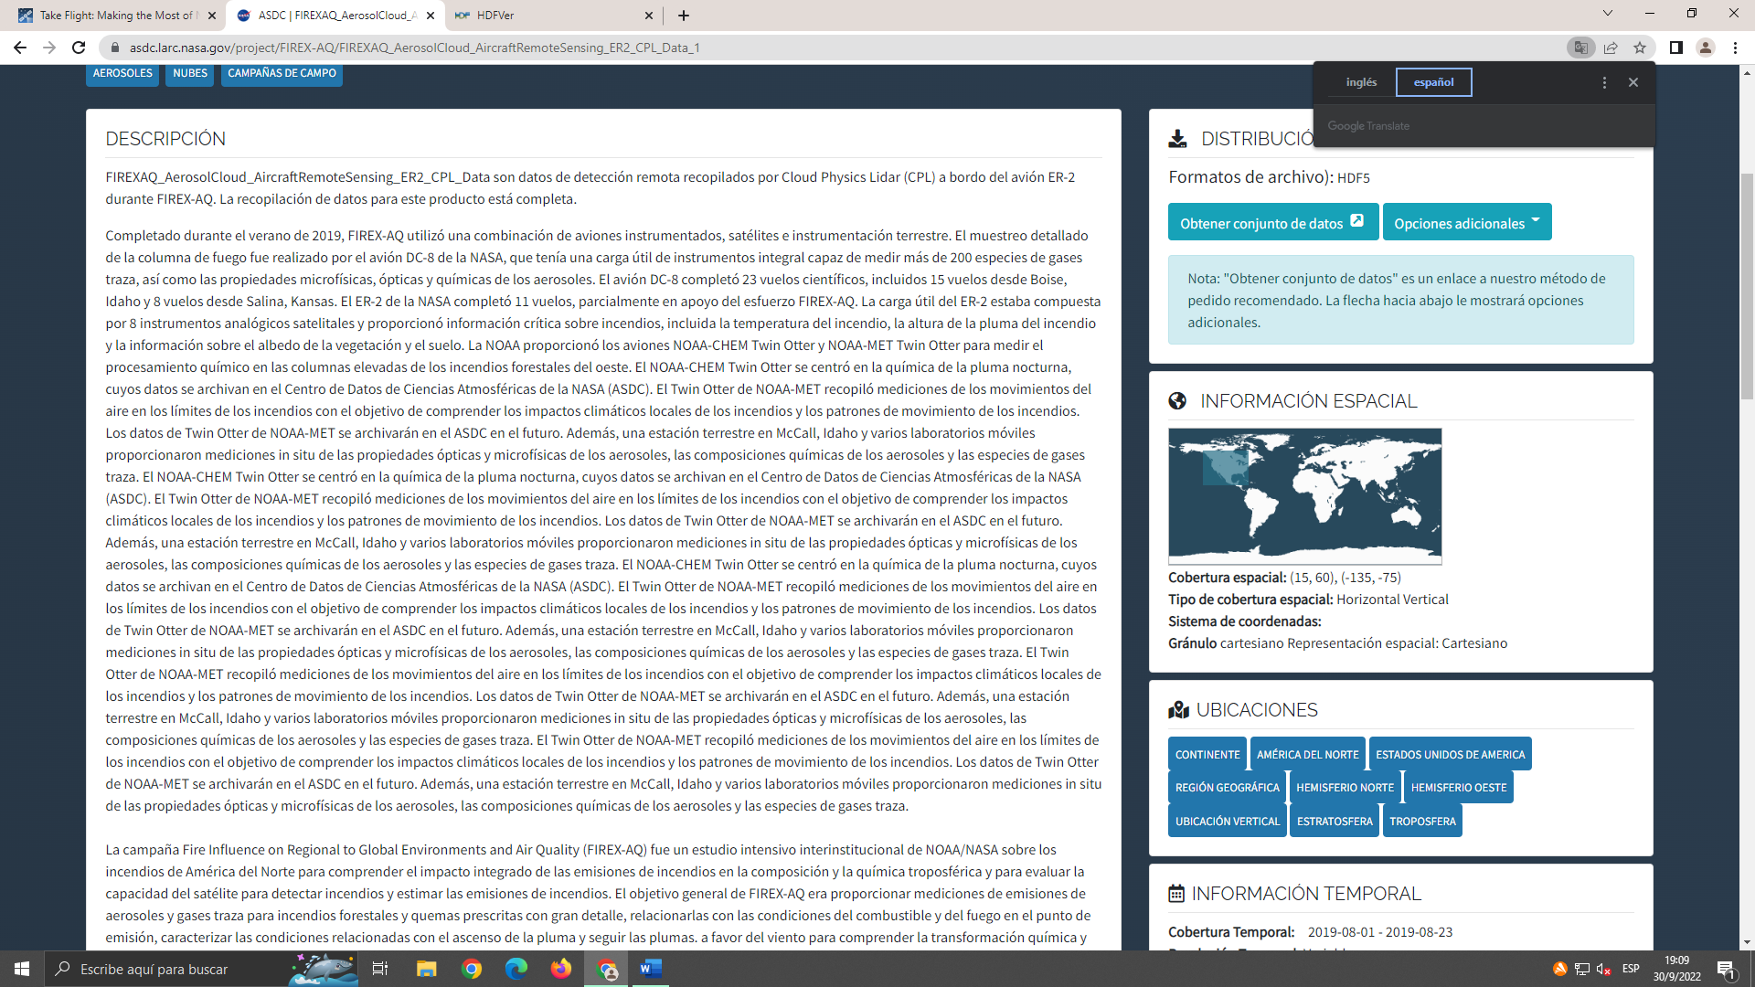 Spatial coverage of FIREX

Completed during the summer of 2019, FIREX-AQ used a combination of instrumented aircraft, satellites, and ground-based instrumentation. Detailed sampling of the fire plume was performed by NASA's DC-8 aircraft. The DC-8 aircraft completed 23 science flights, including 15 flights from Boise, Idaho and 8 flights from Salina, Kansas. NASA's ER-2 completed 11 flights. The ER-2 provided critical fire information, including fire temperature, fire plume height, and vegetation and soil albedo information. NOAA provided the NOAA-CHEM Twin Otter and NOAA-MET Twin Otter aircraft to measure chemical processing in the towering plumes of the western wildfires. The NOAA-CHEM Twin Otter focused on the chemistry of the nocturnal plume, se al (ASDC). NOAA-MET Twin Otter collected measurements of air movements at fire boundaries with the goal of understanding local fire climate impacts and fire movement patterns.

In the province of Córdoba, during the years 1999 and 2017, more than 7,000 ha (hectares) were burned, which include the Sierras Chicas, Sierras Grandes, Sierras del Norte, and Cumbres de Gaspar. These areas were burned at least 4 times or more.

Most fires are of anthropic origin, that is, they are caused or modified by human activity, whether intentionally, accidentally, or negligently.

The fire can also be caused by natural causes such as a lightning strike, but because it occurs in a rainy environment, the humidity prevents the fire from spreading.

Fire is used to renew cattle pastures, replace forest areas with agricultural exploitations, urban developments, open-air dumps (to reduce the volume of garbage or mitigate pests), which is more controllable.

The most important thing to know is that fires are inevitable, but this does not imply that we do not manage the "fuel" load (vegetation), because this will facilitate containment, and thus prevent its spread.

The CONAE Emergency and Early Warning Unit produces satellite images of how the fire evolves in the province (more precisely in the mountains).

**1.2 DATA OBTAINED FROM CONAE ON FOREST FIRES IN CÓRDOBA**

In almost 20 years, fires have damaged an area equivalent to 12 cities in Córdoba. For 19 years, the fire affected 38.3% of the Sierras Chicas, 30.1% of the Sierras Grandes, 15.6% of the Sierras del Norte, and 36.9% of the Cumbre de Gaspar. During the years 1999 and 2017, 5,258 fires were registered in the Sierras de Córdoba.

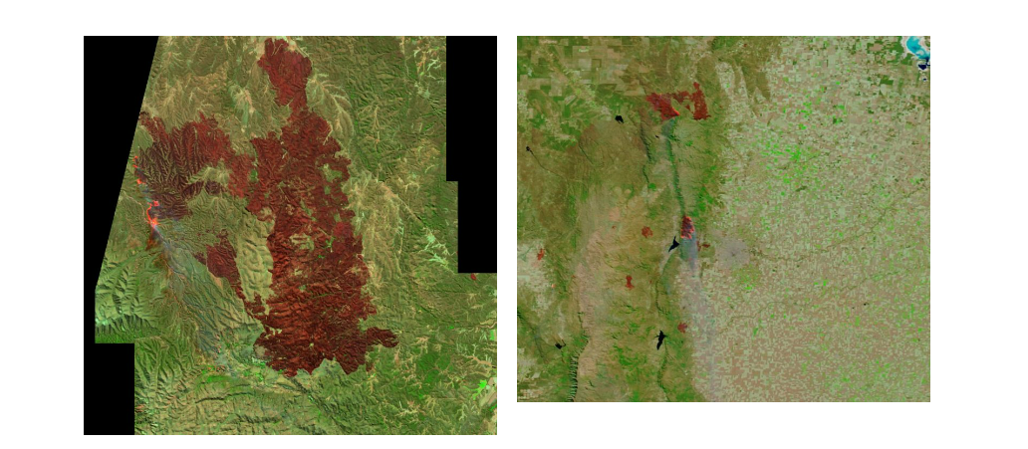

The image on the left was obtained by the Modis sensor on NASA's Terra satellite on August 24, 2020. The image on the right was a view from the Sentinel 2 satellite, one day earlier. The parts with bright red represent the fire fronts and the faint gray ones, the columns of smoke.

**1.21**  **FIRES IN CÓRDOBA DURING 3 DECADES (1987 – 2018)**

58% of the Serrana geography of the province was burned, there were more than 9,000 outbreaks, and around 1.6 million hectares affected. The base consists of 31 georeferenced vector files. Each record was produced from images captured by satellites from the Landsat program of the United States Geological Survey, which were accessed through the Google Earth Engine platform.

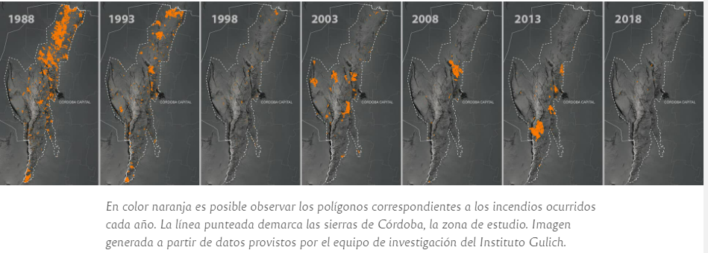



In orange, fires that occur each year are observed. The dotted line demarcates the mountains of Córdoba, the study area. Image generated from data provided by the Gulich Institute research team.

The graphs below present a summary of the information provided by this historical base.

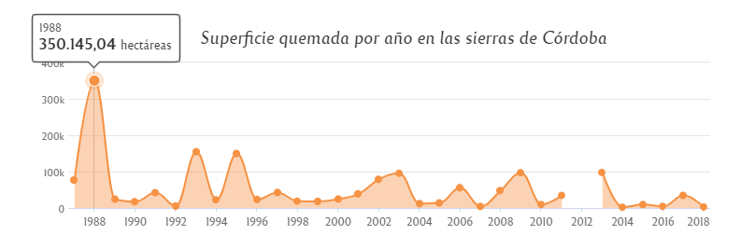

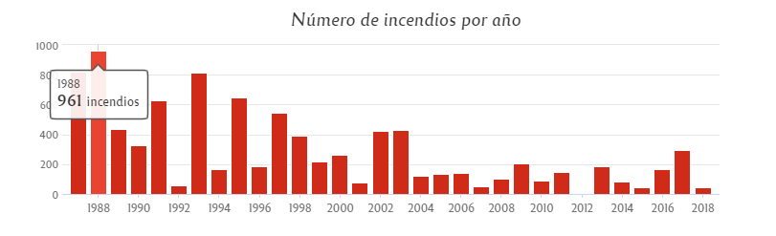

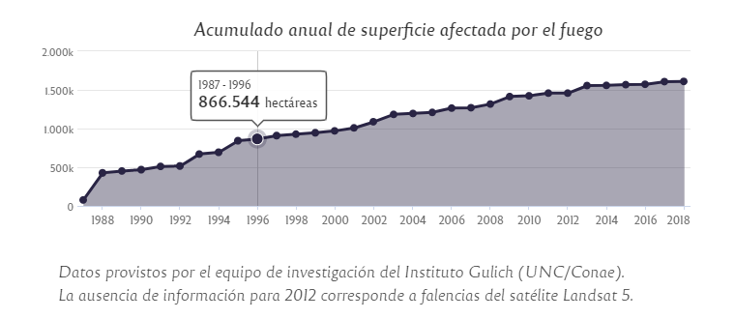

Datos provistos por el equipo de investigación del Instituto Gulich (UNC/Conae).

La ausencia de información para 2012 corresponde a falencias del satélite Landsat 5.

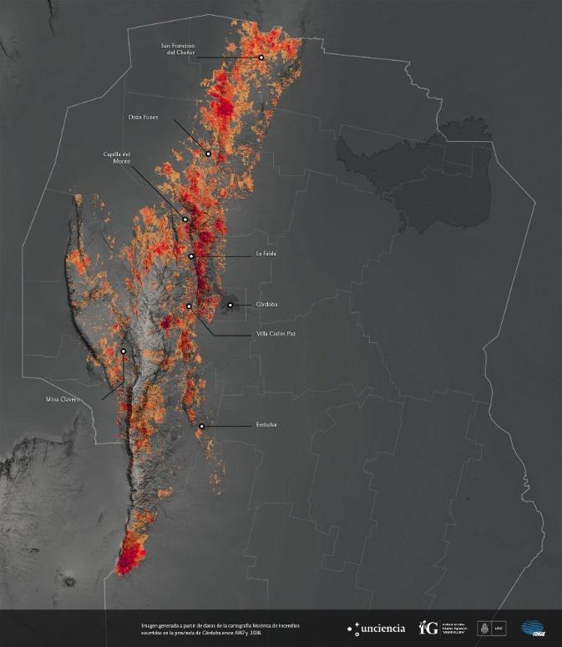

The year 1988 was the worst year analyzed with 961 foci that spread over 350,000 ha. 2015 registered the lowest number of incidents (45). 2014 was the year with the lowest accumulation of burned hectares (2,135 ha). The survey shows that 2.2% of the fires were responsible for 71% of the total area burned between 1987 and 2018. The data on the frequency with which the fires occur showed that 21% of the Sierras burned at least 1 time, 9.5% 2 times, 3.2% 3 times, and about 45,000 ha 4 times.

For the mapping, the research team used satellite images from June 1 to December 31 of each year.

**1.22 AIR POLLUTION (2019-2020)**

Measurements carried out by CONAE from October 1 to October 20, 2020 say that high levels of pollutants were recorded in the air.

Four of the most present contaminants in the air were Nitrogen dioxide (NO2), soot, ash, and dust.

This information was provided by the Sentinel Satellite - 5p of the European Space Agency. In the center of the province, the presence of CO2 increased between 2 and 3 times.

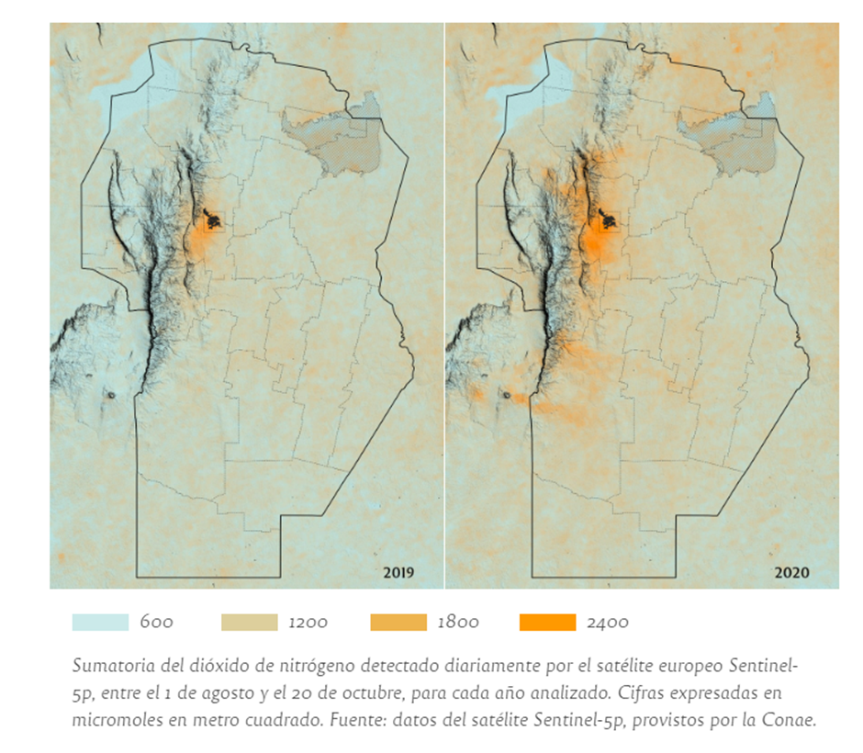

Sum of nitrogen dioxide detected daily by the European satellite Sentinel-5p, between August 1 and October 20, for each year analyzed. Figures expressed in micromoles per square meter.

**Air pollution with nitrogen dioxide | 2019 - 2020**

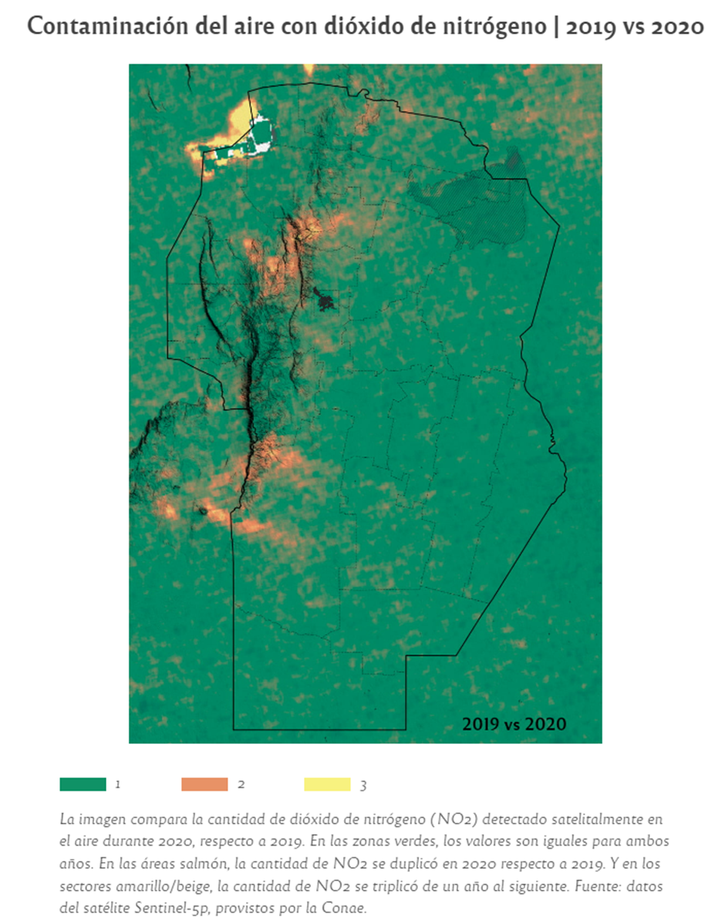

The image compares the amount of nitrogen dioxide (NO2) detected by satellite in the air during 2020, compared to 2019. In the green areas, the values are the same for both years. In the salmon areas, the amount of NO2 doubled in 2020 compared to 2019. And in the yellow/beige sectors, the amount of NO2 tripled from one year to the next. Source data from the Sentinel 5p satellite, provided by Conae.

# Forest fires not only deteriorate the quality of the air, but also the water and, as a consequence, have an impact on people's health.

# The emissions produced by fires in the world contribute 40% of Carbon monoxide, 20% of Nitrogen dioxide and 35% of aerosols (an aerosol is a colloid of solid or liquid particles suspended in gas).

SECTION 2: WHAT IS SAVE YOUR LAND?

Save Your Land is an online video game aimed at a young audience that, with a gradual progress system and events every certain period of time, increase the knowledge of its players by learning more about forest fires in the area of the province of Córdoba.

We have designed an entertaining video game (mainly for the target audience), which combines learning with fun, with the goal of learning quickly without getting bored trying.

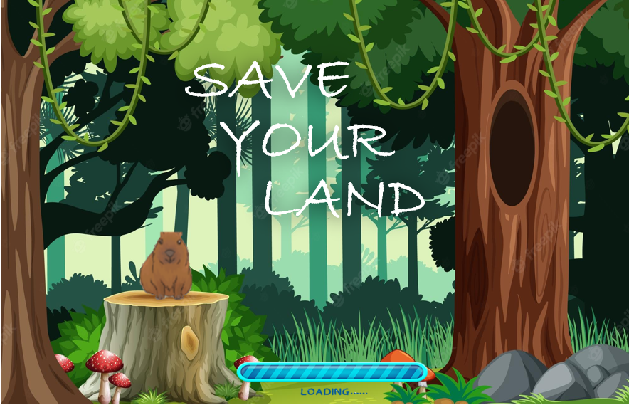

SECTION 3: EXPLAINING THE APPLICATION

**3.1 FROM LEVEL TO LEVEL, FROM ZONE TO ZONE**

The video game consists of a progress system in which the player solves certain problems that arise along the way in order to ensure that our friends, the animals, can remain in their habitats without having to suffer the consequences of forest fires. To advance the level, different problems will occur along the way, whose solution is to answer questions correctly. Every certain number of levels, you will advance from zone.

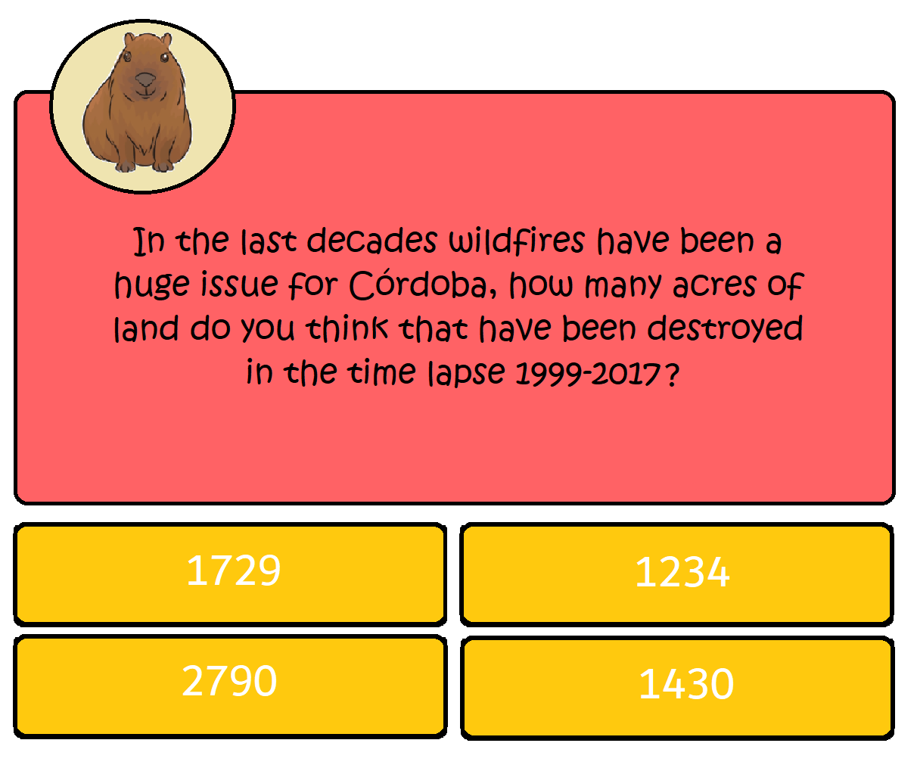

During the course of time, different alerts will occur randomly that will also be solved in the same way as the level advances. If the questions are answered incorrectly, the air quality decreases and the player stays at the level they were before, and after this, they are shown a short video or an explanatory text showing them the error they made when answering, and thus giving feedback to the player to learn and thus motivate them to continue participating in order to level up.

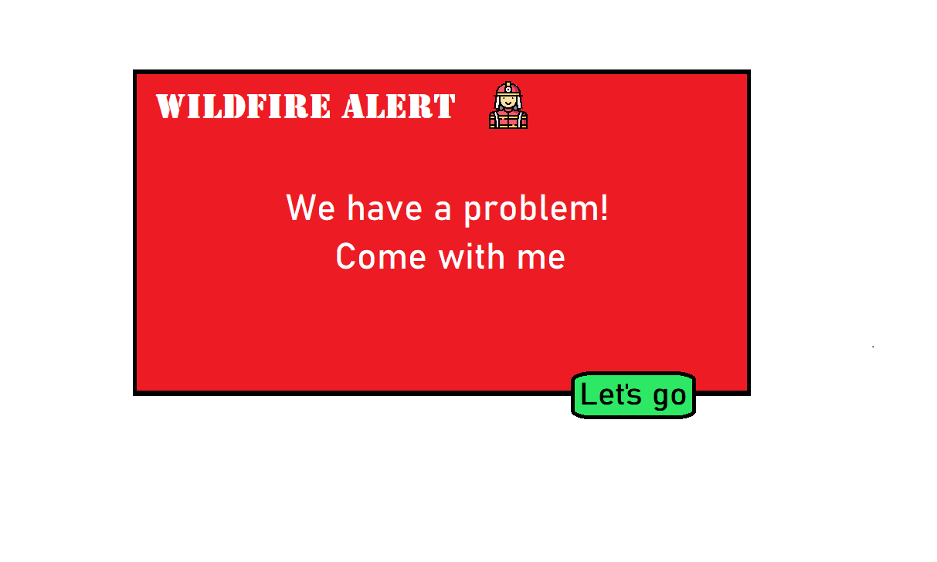

**3.2 OPERATION OF THE APPLICATION**

The application will be a web development, with an intuitive and friendly interface design. Thinking about the public to which it is directed, characters that are native animals in danger of extinction will be used, from which the user can learn their habitat, ecosystem, relationship with other animals, through the history of the game and explanatory videos that They serve to recover air quality.

As a projection of the application, the creation of mini-games that require player actions to add visual attraction and thus produce a pleasant gaming experience is thought of.

Everything related to the costs of carrying out the development and hosting of the application were reduced to the point of having a hosting service (both in the database and in the upload of the project) totally free.

The application will have a responsive design to be able to adapt to any type of device without any inconvenience, adding versatility and universality.

The foundation of the questions and their answers will be totally linked to the information investigated with the CONAE data, that is, the location of the fires, level of NO2 in the air, smoke columns, so that the problem of game, is fully related with the real situation of the ecosystem of the province of Córdoba.

All the questions, their respective answers, images of the new characters and other necessary files will be extracted from the database, and in this case, we chose GCP (Google Cloud Platform), totally free. All this information will reach the web application through queries to the database (CRUD). The Backend of the application will be developed with the Java language, with the help of Spring Boot. Its Frontend will be programmed in the basic web development languages ​​(HTML, CSS, JS) and with the help of Bootstrap and Angular to speed up the time it takes to create the entire graphical interface (more fluid transitions, greater variety of icons, code shortening, etc.).

The web application will be working thanks to free Firebase hosting.

**4.1 MORE INFORMATION**

You can find more information and project documentation at:

https://github.com/SaidSSJ/Save-Your-Land.git

**5.1 SOURCES**

[online] https://csl.noaa.gov/projects/firex-aq/science/motivation.html [visited on 10/01/2022]

[online] https://csl.noaa.gov/projects/firex-aq/science/goals.html [visited on 10/01/2022]

[online] https://csl.noaa.gov/projects/firex-aq/resources/ [visited on 10/01/2022]

[online] https://asdc.larc.nasa.gov/project/FIREX-AQ [visited on 10/01/2022]

[online] https://unciencia.unc.edu.ar/medioambiente/detectan-altos-niveles-de-contaminacion-en-el-aire-por-los-incendios/ [visited on 10/01/2022]

[online] https://www.eldebate.com.ar/quemas-en-casi-20-anos-los-incendios-danaron-una-superficie-equivalente-a-12-ciudades-de-cordoba/ [visited on 10/01/2022]

[online] https://unciencia.unc.edu.ar/medioambiente/el-instituto-gulich-cartografio-los-incendios-que-afectaron-las-sierras-de-cordoba-entre-1987-y-2018/#una-mirada-satelital-para-captar-lo-imperceptible [visited on 10/01/2022]

[online] https://unciencia.unc.edu.ar/medioambiente/detectan-altos-niveles-de-contaminacion-en-el-aire-por-los-incendios/ [visited on 10/01/2022]